**CENWP-OD-B 05 July 2022**

**MEMORANDUM FOR THE RECORD**

**SUBJECT: 22BON028 MFR WA-AWS LPS RB2 PL Mort**

On the morning of 05 July, Bonneville Fisheries discovered one adult Pacific Lamprey mortality in Rest Box 2 (RB2) of the Washington Shore Auxiliary Water Supply Lamprey Passage Structure (WA-AWS LPS). The fish was scanned for PIT tags, inspected, and returned to the river.

1. Species – Pacific Lamprey (*Entosphenus tridentatus)*
2. Origin – Unknown
3. Length – Approximately 74 cm
4. Marks and tags – None
5. Marks and Injuries found on carcass – None
6. Cause and Time of Death – Unknown.
7. Future and Preventative Measures – None

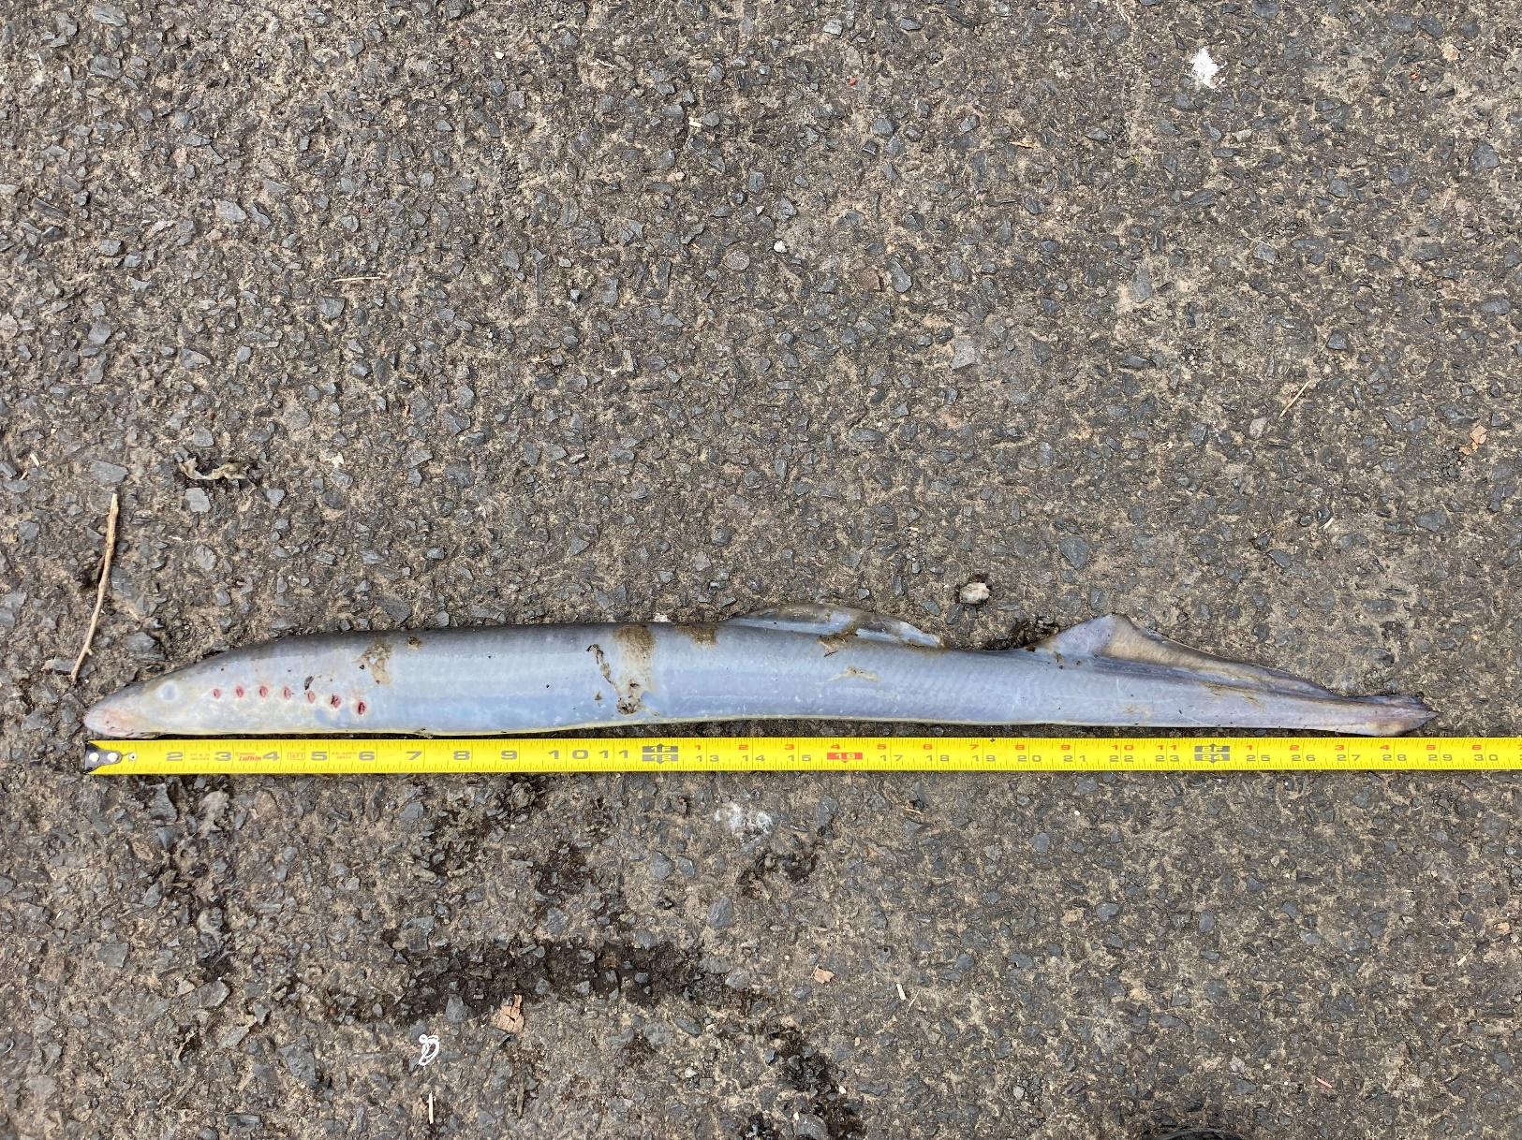

Sincerely,

Bonneville Project Fisheries